欧州タクシー事情補足資料

●１５６●Hailo
https://en.wikipedia.org/wiki/Hailo
●157●Maaxi
https://www.maaxitaxi.com/
●158●Uber
https://www.uber.com/
http://www.jinryu.jp/category/lecture/file
○ブラックキャブ
○ミニキャブ
○ロンドン交通局Transport for London (TfL)
TfL is a local government body responsible for most aspects of the transport system in Greater London in England. Its role is to implement the transport strategy and to manage transport services across London.^{[1]} Its head office is in Windsor House in the City of Westminster.
TfL Taxi and Private Hire office
The Taxi and Private Hire office is the body responsible for licensing taxicabs within Greater London. Taxi and Private Hire is part of Transport for London and is responsible for licensing the familiar London taxicab or "black cab" and also licenses private hire or minicab services. "Black cabs" were traditionally coloured black, but this is not a requirement and cabs are painted in other colours, sometimes bearing advertising; however they are traditionally called black cabs to distinguish them from minicabs.

○The Knowledge
Private hire (minicabs)
In London the term minicab is used to refer to a private hire car and "private hire" is used in the rest of the United Kingdom; that is a car with a driver available for hire only on a pre-booked basis. They began operating in the 1960s in competition with hackney carriages after a loophole in the law was spotted (although in some areas it is possible to hold a dual hackney/private hire licence). A minicab must be booked, for example, by telephone, internet, or fax, or in person at the registered minicab office. A minicab can be booked at the time it is required, but only at the office of a company registered to accept bookings rather than directly with a driver.
Since 2001 minicabs have been regulated in London and most other local authorities. London minicabs are now licensed by London Taxis and Private Hire, or LTPH, formerly known as the Public Carriage Office. This is the same body that regulates London's licensed taxicabs, but the minicab drivers do not have to complete The Knowledge, though they must undergo a topographical test in order to obtain a Private Hire Drivers' Licence. All vehicles available for hire by London minicab drivers must hold a LTPH licence showing that they are fit for purpose; this is updated twice a year after an inspection at a licensed garage. In London new applicants must send their Topographical Skill Certificate along with their application to the PHV Driver Licensing Section of the LTPH .

The Knowledge
The taxicab driver is required to be able to decide routes immediately in response to a passenger's request or traffic conditions, rather than stopping to look at a map, relying on satellite navigation or asking a controller by radio. Consequently, the 'Knowledge' is the in-depth study of a number of pre-set London street routes and places of interest that taxicab drivers in that city must complete to obtain a licence to operate a black cab. It was initiated in 1865, and has changed little since. It is claimed that the training involved ensures that London taxi drivers are experts on London, and have an intimate knowledge of the city.
It is the world's most demanding training course for taxicab drivers and applicants will usually need at least twelve 'appearances' (attempts at the final test), after preparation averaging 34 months, to pass the examination.

Types of cab
Hackney carriages (taxis) can be flagged down in the street or hired from a taxi rank.
Private hire vehicles ('minicabs') are passenger vehicles which can be either a 4 door saloon/hatchback, carrying up to four passengers or MPVs that are licensed to carry between 5 and 8 passengers. These may not be hailed in the street.
Chauffeur cars are a sub-set of private hire; generally a higher-value car such as a Mercedes or Jaguar where the passenger pays a premium but in return receives a higher level of comfort and courtesy from the driver, some of whom wear a uniform.

Computer Cab plc

A member of ComfortDelGro, and within the CityFleet UK structure,
Computer Cab plc is the market leader supplying taxi booking and account services in the UK. CityFleet, operating in four cities in the UK and under several local brands, provide a fast reliable service for business users and the general public. International service is also available for Account Customers through Cabcharge International.
Customers enjoy peace of mind and we provide exceptional management reporting for larger businesses.

Hailo

Hailo is a British new technology platform that matches taxi drivers and passengers through its mobile phone application. Founded in London in 2011, the Hailo taxi service is available in 16 cities (as of December 2013).As of May, 2013, Hailo has enabled more than 3 million rides for passengers from over 30,000 registered taxi drivers.
The Hailo Passenger App is available as a free download from the App Store and GooglePlay forboth iOS and Androiddevices. Hailo began in late 2010, after a meeting between three London taxi drivers and three technology entrepreneurs, including co-founders Jay Bregman, CEO, Ron Zeghibe, Executive Chairman, Caspar Woolley, Chief Operations Officer, and Russell Hall, Gary Jackson, and Terry Runham, Driver Community Leaders.
On November 1, 2011 Hailo officially launched to passengers in London. By the end of 2012, Hailo had launched in Dublin, Boston, Toronto, and Chicago. As of late 2013, the company is fully available in New York City and has announced the launches of services in Madrid, the rest of Ireland, Barcelona, Washington DC, Tokyo and Osaka by the end of the year.

Funding
To date, Hailo has raised approximately $125.1 million in funding. Hailo received $3.0 million in two tranches of Seed round funding in 2011. In March 2012, Hailo received $17m in Series A round funding led by Accel Partners. The round also included contributions from both Atomico and Wellington Partners. A $30.6m Series B investment round was secured in December 2012, lead by Union Square Ventures. Contributions were also made by Japanese mobile telecoms group KDDI and business magnate Sir Richard Branson.
A survey conducted by Hailo found that cab drivers spend an average of 40-60 percent of their time looking for fares.
The Hailo mobile e-hail application uses mobile and GPS technology to match taxi drivers with passengers based on both availability and proximity. Hailo passengers make two taps on the Hailo smartphone app in order to request and confirm their e-hail. Once a driver has electronically accepted a passenger, the waiting passenger is sent an updated time of arrival based on route information and real-time traffic information.
Customers also have the ability to specify if they require a wheelchair-accessible vehicle or a fixed price fare to designated location such as an airport terminal, where permitted. The Hailo driver app includes social networking features, which allows drivers to alert each other of locations with high street fare demand, traffic conditions, speed traps and road construction obstacles. Both the Hailo passenger and driver apps are compatible with both iOS and Android mobile devices.
Hailo enables its registered passengers to e-hail, pay and tip for taxi journeys using the credit or debit card details they have stored within Hailo's secure cloud wallet.
In some city locations, taxi drivers can also use Hailo to process credit and debit card payments for street hail fares by manually entering passenger card details when they reach their destination.
Instant trip receipts are sent to passengers by email and contain journey and payment information along with instructions to help retrieve any property lost or forgotten in the taxi.

Legal proceedings
In February 2013, Black Car Assistance Corporation and Livery Roundtable filed a lawsuit against the taxi and limousine commission to prevent e-hailing companies from expanding to New York City. In April 2013, a judge dismissed the lawsuit and Hailo won the right to begin an e-hail beta trial. The decision was subsequently appealed. After a second temporary restraining order was issued against the pilot program, Hailo became the only taxi-hailing app-maker to join the lawsuit in support of the city.

Taxi app Hailo has complained rival Uber has blocked potential investors from offering funding.
Speaking to the BBC, Hailo chairman Ron Zeghibe alleged Uber would talk to potential investors only if they agreed not to invest in Hailo or other rivals.
Hailo recently abandoned its business in North America, saying it could not compete with Uber's "astronomical marketing spend".
Uber said it did not wish to respond to Mr Zeghibe's remarks.
However, other sources close to the taxi app industry said Uber was acting with "common sense" and protecting itself from having its ideas stolen.
Uber recently secured $1.2bn (£750m) in funding, valuing the company at $18bn.
Mr Zeghibe told the BBC: "[Uber] can spend money like drunken sailors."
He added: "In raising that massive [funding] round, any investor who wanted to even look at Uber's books to decide whether they wanted to make an investment had to sign an agreement which specifically named us, as well as Lyft, and restricting them from having any ability to even talk to us for at least a year.
"It wasn't just good enough for them to raise enough money for their business - they needed to restrict the market to Hailo and its competitors to have access to capital.
"That's what we're up against."

'Mug's game'
Hailo's comments came following an announcement about new features on the service, which has expanded to Leeds and Liverpool, and is also being rolled out in Singapore.

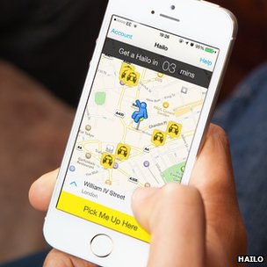Hailo cabs appear live within the company's app
Of the new features announced, Pay With Hailo stood out the most - a way of using a Hailo account to pay for taxis hailed off the street, at no additional cost to the driver.
Hailo also waded into the debate around public transport regulation, calling upon the UK government to be stronger in enforcing public transport rules.
"It becomes very hard to play by the rules if no-one else is," Mr Zeghibe said. "It's a mug's game."
He argued that Uber drivers should face the same costs, and training requirements, as black-cab drivers who have to earn the right to be able to pick people up on the street and charge by the meter.
Many black-cab drivers insist that Uber's system - where a journey cost is determined at the end of the trip - amounts to a meter, and therefore drivers should be forced to comply.
Private hire vehicles, by contrast, state an agreed price at the start of a journey, and must be booked through a central office, rather than on the street.
Transport for London (TFL) has said it did not believe Uber was in breach of the rules.
It has so far ruled that as Uber requires booking a car on a central system, it should be considered a private hire vehicle.
However - it has referred the issue to the High Court for a final judgement on Uber's legality.
Hailo is concerned this process is taking too long.
"This thing is moving so fast, and the technology evolves so quickly, that it will be a fait accompli," Ron Zeghibe, Hailo's chairman, told the BBC.
"In the end it is up to the politicians to decide where the public interest is and make sure there are the rules available to protect that interest. Right now, with the rapid changes going on, they better take some actions quickly.
"If they don't, they're going to find out that the public interest will be defined by the tech companies."
But Hailo's relationship with black-cab drivers has not always been steady.
It lost a lot of support earlier in the year by applying for a licence to operate private hire cars as well as black cabs which some cab drivers felt was a betrayal of trust. Around the city, drivers were displaying mock logos reading "Failo".
In the midst of the furore, a new competitor, Maaxi, began recruiting black-cab drivers disgruntled with Hailo.
The Licensed Taxi Drivers Association (LTDA) is currently in the process of taking several individual Uber drivers to court.
TFL's decision is to be reviewed by the High Court - but only after the LTDA action has concluded.

Because [Uber] are not actually a cab firm, they are just a software firm, they're just a third party that passes on the jobs, they are able to charge much more competitive prices, and are able to pay the drivers a great deal more as well."

○http://www.bbc.com/news/technology-27733971
BBC 8 June 2014 Last updated at 23:12 Uber versus black cabs: Battle lines drawn
By Dougal Shaw Technology reporter
Jump media player
Media player help
Out of media player. Press enter to return or tab to continue.
Get in the cab with an Uber driver and a black-cab driver to hear their views
A clash is about to take place on the capital's streets that sees the old pitted against the new. The livelihoods of London's iconic cabbies are at stake. But could they be stifling opportunities for a new breed of driver - that could even include you?
London's black-cab drivers are preparing to cause gridlock in the capital on Wednesday, in protest at Transport for London's stance towards a mobile phone app that allows users to book private vehicles, using GPS technology to set the fare.
It's the hottest topic of conversation amongst cab drivers since Olympic traffic lanes. What should be done about Uber?
Black-cab driver Lloyd Baldwin is in no doubt. "Our beef with Uber is that these drivers have come straight into London, and have been licensed straight away by Transport for London. We're regulated to within an inch of our lives.
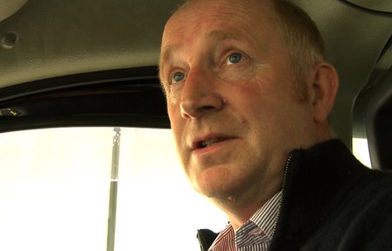
Lloyd Baldwin has been a black cab driver for nearly 20 years

"We don't do protests willy-nilly for petty things, we feel it's our only course.
"We just want them to be treated exactly the same as we are."
The issue of "regulation" covers a multitude of sins as far as the black-cab drivers are concerned, from the extent to which Uber drivers are security-vetted to a driver's profit margins.
But perhaps the battle can best be summed up by two symbols that sit proudly on each rival's dashboard: the fare-calculating taximeter and the smartphone.
Curb competition
In the five years of its existence, San Francisco-based Uber has expanded its operation into more than 100 cities across 30 countries, causing conflict in its wake with traditional taxi associations.
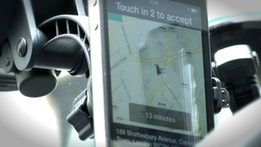
Uber drivers receive jobs through their smartphones
Its proposition is simple: users download an app to their mobile which they use to book cabs, wherever they may be. That much has already been offered to Londoners by firms like Kabbee and Hailo.
Uber has provoked controversy because of its pool of drivers. Anyone with a Private Hire Vehicle (PHV) licence can sign up with them. This has allowed Uber to build up a vast number of drivers quickly, many of whom only work part-time.
This makes Uber more like a minicab firm. But unlike a traditional minicab firm, there are no human operators available to take your booking on the phone at their offices. The process is completely automated by Uber's software, which allocates your booking to the driver best placed to take it on.
Uber evangelist
Ben John never imagined he would end up driving a cab round London.
Ironically, it was the digital revolution that got him into this situation. A successful A&R man for over a decade in the music industry, his profit margins suddenly shrunk as music downloads disrupted the record labels' business model.
For him, Uber has been a lifeline, providing him with lucrative, flexible work as he establishes his new start-up business selling e-cigarettes.
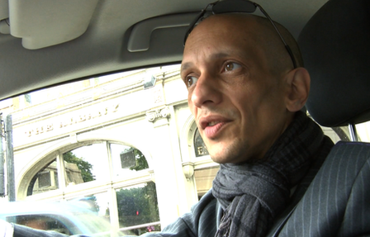
For Ben John, driving for Uber is a short-term move as he switches career

Evidently grateful, he has become something of an Uber evangelist.
"You can log in and off from work as you want to, which allows you to do other things with your day," he says, while keeping an eye on the phone protruding from his dashboard.
"Because [Uber] are not actually a cab firm, they are just a software firm, they're just a third party that passes on the jobs, they are able to charge much more competitive prices, and are able to pay the drivers a great deal more as well."
A lack of overheads allows Uber to offer drivers 80% of the customer's fare.
Ultimately, Mr John doesn't think that Uber threatens the black cab trade.
"What I'm seeing is that Uber are actually expanding the number of people who would otherwise not use minicabs."
Back to black
From the comfort of his black cab, Lloyd Baldwin begs to differ. "We're not afraid of competition. We've faced competition from minicabs for 40 years."
But in this case, Mr Baldwin believes the competition is not on a level playing field.
"Transport for London now aren't sure if they [Uber] should have been given a licence or not, hence they've gone to the High Court for a judgment on it, but they still licensed them before they were sure."
The issue at stake is whether Uber's use of the smartphone equates to a taximeter, a talismanic object for black cab drivers, which they feel only they have the right to use.
TfL's original position was that it did not believe Uber was infringing the law because its kit did not require a physical connection between the device and the vehicle, as is the case with the equipment used by black cabs.
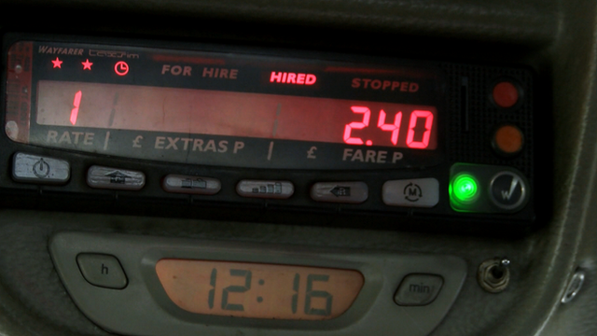The meter is a talismanic device for black cab drivers, and is at the heart of the conflict

The Licensed Taxi Drivers Association (LTDA) dispute this.Mr Baldwin wonders why Uber was able to introduce the smartphone as a way of measuring fares without more scrutiny. "We suspect that they [Uber] are backed by big, multi-billion pound companies," he says.His suspicion extends to Amazon, which is not in fact connected to Uber. However, Goldman Sachs and Google do offer it financial backing.
Uber evangelist Ben John is careful to always refer to his smartphone as a "GPS device", rather than a meter, and is keen to talk up its benefits.
"The difference is that there is actually a lot of recourse if you believe as a customer that your driver is taking an overly long route, you can go back to Uber, and the price given back to you if need be."
You can also nominate a friend or loved-one to track your journey, as a security feature.
However, GPS-tracking could also be the Achilles heel of the firm, if data privacy fears arise. Uber has already handed over details on some of its customers' journeys to the authorities. By law, minicab and black-cab firms have to do the same, but they simply don't record their customer's journeys in the same level of digital detail.
Uber allies?
The cause of the black-cab drivers recently suffered a reverse with the announcement that app Hailo - which at first offered its services only to black cabs - would be working with private-hire vehicles.
"We feel that they used us to give them a place in the market, they used our reputation and our good name," says Mr Baldwin.
"We just feel used by Hailo," he says, with more bitterness in his voice than he reserves for Uber or TfL.
Twenty years ago, he explains, when mobile phones were still uncommon objects, he invested three very tough years of his life learning to become a black-cab driver. He devoted long hours to learning The Knowledge, the fabled test of a driver's memory of London's sprawling streets, which also includes a psychological test to see how you deal with difficult customers.
He thought those years of hardship were worth it, because he was earning a lifetime of guaranteed work, and the badge of pride that is the black cab.
But Uber and Hailo appear to be taking a bet on a different future where there is no meaningful distinction between black cabs and minicabs.
It's this vision of the future that the black cabbies are protesting against on Wednesday.

BBC 8 May 2014 Last updated at 12:22
London black taxis plan congestion chaos to block Uber
By Dave Lee & Leo Kelion Technology, BBC News
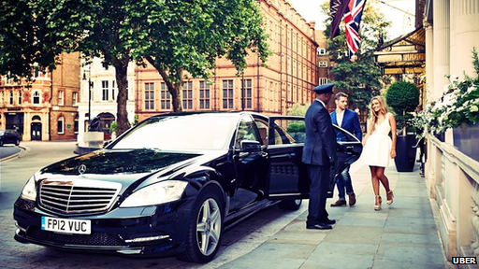Uber launched its car-hire service in London in June 2012
- France mulls GPS car-sharing app ban
- Car-share firm faces lawsuit
- Catching a taxi will never be the same
London black-cab drivers are planning to cause gridlock in the city to protest against car service Uber. The Licensed Taxi Drivers Association complains that Uber's drivers are using a smartphone app to calculate fares despite it being illegal for private vehicles to be fitted with taximeters. Transport for London has declined to intervene, because it disagrees that there has been a breach of the law. LTDA now plans to force the issue by holding the action in early June."Transport for London not enforcing the Private Hire Vehicles Act is dangerous for Londoners," Steve McNamara, LTDA's general secretary, told the BBC."I anticipate that the demonstration against TfL's handling of Uber will attract many many thousands of cabs and cause severe chaos, congestion and confusion across the metropolis." TfL told the association last month that it believed Uber's vehicles were not strictly "equipped" with taximeters since there was not "some sort of connection between the device and the vehicle".
Rather, the app was merely making use of data about the distance travelled and time taken, which was not illegal in itself.
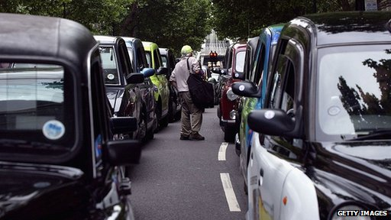
The LTDA says it expects many thousand black cab drivers to take part in the protest

LTDA rejects this distinction and is now threatening to seek a judicial review. "We have seen no evidence to suggest that Uber London Ltd are not fit and proper to hold a London private hire vehicle operator's licence, but no final decisions have been made whilst Uber's operating model is still under investigation," TfL told the BBC. The dispute marks the latest in a series of clashes between Uber and the established taxi trade. The firm is also facing restrictions on its operations in Paris, Brussels, Berlin, Sydney and a number of US cities.

Disruptive drive
San Francisco-based Uber describes itself as a "pick-up" service that connects those needing a ride with a background-checked private driver, and takes a cut - typically 20% - of the fee. It now operates in more than 100 cities across 30 countries, including Manchester where it launched this week. The firm markets its service as offering "cutting-edge safety measures":
allowing customers to see the name and photo of the driver before they arrive
letting approved friends follow the journey on a live map
providing an email of the route the car used, so that a client can ask for a charge to be reviewed if they believe the driver took a roundabout journey
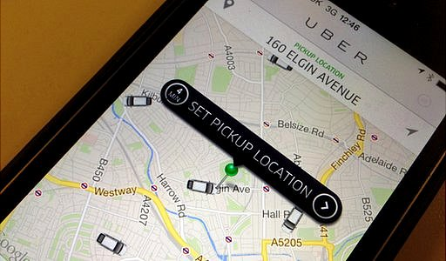
The Uber app allows customers to see how many available drivers are nearby

Fees are based upon data gathered by the driver's app and whether "surge pricing" is in effect because of heavy demand.
The five-year-old firm acknowledges that it can prove a disruptive force.
"Competition in my view is always good for the customer because it makes all of us up our game in terms of quality and service," Uber's general manager in London, Jo Bertram, said. "On the driver side, we offer a much more flexible model that is very different from the old-school private hire industry, that allows them to work as independent business operators however and whenever they choose."
The LTDA said while the taximeter was the focus of its complaint, it had wider objections to the firm. "Uber, funded by Google, Goldman Sachs and others, has a stated aim of challenging legislation that is not compatible with its business model," said Mr McNamara. "This is not some philanthropic friendly society, it's an American monster that has no qualms about breaching any and all laws in the pursuit of profit, most of which will never see a penny of tax paid in the UK." A spokeswoman for Uber said it rejected this characterisation of its business,

European battles
Other traditional taxi associations are also taking a stand against the firm in Europe:
- In Brussels a complaint resulted in a court setting a 10,000 euro ($13,920; £8,205) fine as the penalty for Uber drivers who continued to pick up customers without the necessary licences
- Berlin's taxi association has won a temporary injunction against the firm, but has chosen not to enforce the action to avoid the risk of having to cover lost fees if the ruling is later overturned
- French operators have convinced their government to propose banning the use of GPS-enabled apps by private car services including Uber. The government had previously made such companies wait 15 minutes before picking up a booking, but the country's Supreme Court ruled the move anti-competitive
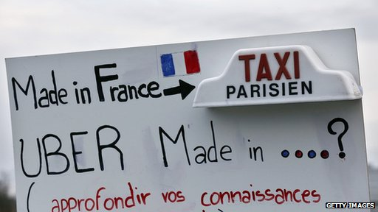
French taxi drivers have opposed Uber's service in Paris

Uber does, however, have support from the European Commission. Vice-president Neelie Kroes has said her staff used the service to "stay safe and save taxpayers money", adding that European authorities should help the firm comply with standards rather than trying to ban it.
"We very much welcome her support and her comments," said Ms Bertram.

Private Hire Vehicles (London) Act 1998
http://www.legislation.gov.uk/ukpga/1998/34/contents
- Introductory Text
- Introductory
  - 1. Meaning of “private hire vehicle”, “operator” and related expressions.
- Regulation of private hire vehicle operators in London
  - 2. Requirement for London operator’s licence.
  - 3. London operator’s licences.
  - 4. Obligations of London operators.
  - 5. Hirings accepted on behalf of another operator.
- Regulation of private hire vehicles in London
  - 6. Requirement for private hire vehicle licence.
  - 7. London PHV licences.
  - 8. Obligations of owners of licensed vehicles.
  - 9. Fitness of licensed vehicles.
  - 10. Identification of licensed vehicles.
  - 11. Prohibition of taximeters.
- Regulation of drivers of private hire vehicles in London
  - 12. Requirement for private hire vehicle driver’s licence.
  - 13. London PHV driver’s licences.
  - 14. Issue of driver’s badges.
- Licences: general provisions
  - 15. Applications for licences.
  - 16. Power to suspend or revoke licences.
  - 17. Suspension and revocation under section 16: procedure.
  - 18. Variation of operator’s licence at the request of the operator.
  - 19.Variation of operator’s licence by the licensing authority.
  - 20. Fees for grant of licences, etc.
  - 21. Production of documents.
  - 22. Return of licences, etc.
  - 23. Register of licences.
  - 24.Delegation of functions by the licensing authority.
  - 25. Appeals.
  - 26. Effect of appeal on decision appealed against.
  - 27. Obstruction of authorised officers etc.
  - 28. Penalty for false statements.
  - 29. Saving for vehicles used for funerals and weddings.
- Further controls
  - 30. Prohibition of certain signs, notices etc.
  - 31. Prohibition of certain advertisements.
- Miscellaneous and supplementary
  - 32. Regulations.
  - 33. Offences due to fault of other person.
  - 34. Service of notices.
  - 35. References to the owner of a vehicle.
  - 36. Interpretation.
  - 37. Power to make transitional etc. provisions.
  - 38. Financial provisions.
  - 39. Consequential amendments and repeals.
  - 40. Short title, commencement and extent.
- SCHEDULES
  - Expand +
SCHEDULE 1
Minor and consequential amendments
  - SCHEDULE 2
Repeals

11Prohibition of taximeters.
(1)No vehicle to which a London PHV licence relates shall be equipped with a taximeter.
(2)If such a vehicle is equipped with a taximeter, the owner of that vehicle is guilty of an offence and liable on summary conviction to a fine not exceeding level 3 on the standard scale.
(3)In this section “taximeter” means a device for calculating the fare to be charged in respect of any journey by reference to the distance travelled or time elapsed since the start of the journey (or a combination of both).

13London PHV driver’s licences.
(1)Any person may apply to the [F1licensing authority] for a private hire vehicle driver’s licence for London (in this Act referred to as a “London PHV driver’s licence”).
(2)The [F1licensing authority] shall grant a London PHV driver’s licence to an applicant if [F2the authority] is satisfied that—
(a)the applicant has attained the age of 21, is (and has for at least three years been) authorised to drive a motor car and is a fit and proper person to hold a London PHV driver’s licence; and
(b)the requirement mentioned in subsection (3), and any further requirements prescribed by the [F1licensing authority], are met.
(3)The [F1licensing authority] shall require applicants to show to [F2the authority’s] satisfaction (whether by taking a test or otherwise) that they possess a level—
(a)of knowledge of London or parts of London; and
(b)of general topographical skills,
which appears to [F2the authority] to be appropriate.
The [F1licensing authority] may impose different requirements in relation to different applicants.
(4)The [F1licensing authority] may send a copy of an application to the Commissioner of Police of the Metropolis or the Commissioner of Police for the City of London with a request for the Commissioner’s observations; and the Commissioner shall respond to the request.
(5)A London PHV driver’s licence—
(a)may be granted subject to such conditions as the [F1licensing authority] may think fit;
(b)shall be in such form and shall contain such particulars as the [F1licensing authority] may think fit; and
(c)shall be granted for three years or for such shorter period as the [F1licensing authority] may consider appropriate in the circumstances of the particular case.
(6)An applicant may appeal to a magistrates’ court against a decision not to grant a London PHV driver’s licence or against any condition to which such a licence is subject.
(7)For the purposes of subsection (2), a person is authorised to drive a motor car if—
(a)he holds a licence granted under Part III of the M1Road Traffic Act 1988 (other than a provisional licence) authorising him to drive a motor car; or
(b)he is authorised by virtue of section 99A(1) or 109(1) of that Act (Community licences and Northern Ireland licences) to drive a motor car in Great Britain.

29 May 2014 Last updated at 08:58
Uber app taxi row referred to London's High Court
By Leo Kelion Technology desk editor

London's transport authority has announced it does not believe Uber's car service is breaking the law by using an app to determine charges.
However, Transport for London added it would invite the High Court to give a binding ruling on the matter "given the level of concern among the trade".
The Licensed Taxi Drivers Association (LTDA) has claimed the app equates to being a taximeter, which private vehicles are not allowed to use.
It plans a demonstration on 11 June.
The organization announced the action earlier this month, saying it intended to cause "severe congestion and traffic chaos for large parts of central London".
It confirmed that TfL's announcement would not change its plans.
High Court ruling
The controversy centres on an app provided to Uber's drivers - which is separate from the one used by the public - that calculates the journey distance and time taken, and then relays this information to remote computer servers to determine the fee. TfL's decision is based on the fact that Uber's kit does not require a physical connection between the device and the vehicle, as is the case with the equipment used by black cabs. However, it added that "the rapid pace at which smartphone-based technology has been developing in recent years" meant the matter should be referred to a judge. "We will be asking the High Court to provide a binding ruling," added Leon Daniels, TfL's managing director of surface transport. "This is the sensible approach, and we hope that London's taxi drivers and private hire drivers and operators will work with us to bring clarity on this issue." However, LTDA is in no mood to co-operate, and highlights the fact that the handsets Uber provides to drivers are blocked from making calls. "The taxi trade have no confidence in TfL and its legal team whatsoever and we will be issuing proceedings of our own," its general secretary Steve McNamara told the BBC. "This attitude demonstrates why we are being forced to demonstrate. TfL is simply not fit for purpose." However, Uber's London manager proved more receptive. "We very much welcome TfL's announcement today bringing clarity and confirming that TfL and Uber fully share the vision that technology should be a key driver in changing the way people are moving around their city, improving the experience for both riders as well as drivers," said Jo Bertram.
Driverless Uber
San Francisco-based Uber describes itself as a "pick-up" service that connects those needing a ride with a background-checked private driver. It then takes a cut - typically 20% - of the fee. It now operates in more than 100 cities across 30 countries. In the UK it covers London and Manchester, but has plans to expand to a further four or five cities over the next year. The firm highlights both the safety features offered to customers - letting them see the name and photo of the driver before they arrive - as well as offering the drivers themselves the flexibility to set their own hours and the area where they want to work.
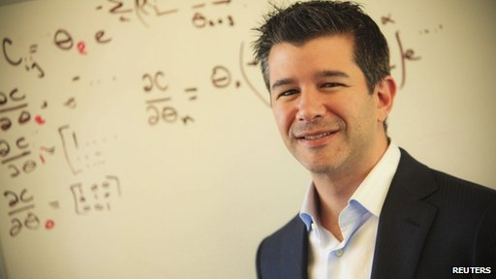
Uber's chief executive says he believes Uber will offer driverless pick-ups in the future

However, comments by the firm's chief executive on Wednesday may give some potential recruits reason to pause. Travis Kalanick told an audience in California the firm's long-term plan was to replace drivers with self-controlled cars. His comments followed Google's announcement that it would start building its own self-drive vehicles - the search giant is one of Uber's investors. "Look, this is the way the world is going," Mr Kalanick said, when questioned about how he would explain this to the workers. "If Uber doesn't go there, it's not going to exist either way... the world isn't always great."
He later tweeted that he thought the move would take a couple of decades to achieve.
But the timing of his comments offers the LTDA another way to attack a firm it has already described as an "American monster".
"Its drivers can work very flexibly, they can stay at home all day if they work for Uber - they'll be unemployed," said Mr McNamara.
"I think driverless cars are still very much a Star Wars technology. While it may work in some cities in the distant future, I cannot see it working in a city like London with the complex layout of its streets."

3 October 2014 Last updated at 12:22

Uber boss Travis Kalanick: I'm no bully

Uber boss Travis Kalanick: I'm no bully
Jump media player
Media player help
Out of media player. Press enter to return or tab to continue.
Rory Cellan-Jones talks to Uber co-founder Travis Kalanick
The boss of the rapidly-expanding taxi service Uber has told the BBC he is not bullying local taxi firms and drivers. "There's probably some misunderstanding of who I am and how I roll," Travis Kalanick told BBC World Service technology programme Tech Tent. His firm has been criticized for what some have described as aggressive business practices in cities around the world. "That's just simply not the case," he said. "We have worked with regulators." He also dismissed claims he had been rude about taxi drivers at a technology conference, saying he had been misquoted. "I've never been derogatory towards taxi drivers," he said. "In the US there's basically a cartel of taxi companies, I was referring to them."
Choice
Since being founded in San Francisco in 2009, Uber has grown into a huge ridesharing enterprise - with services now offered in more than 200 cities. Unlike a traditional minicab firm, there are no human operators available to take your booking on the phone at their offices. Instead, once a user requests a lift through an app, the process is completely automated by Uber's software which allocates the booking to the driver best-placed to take it on.
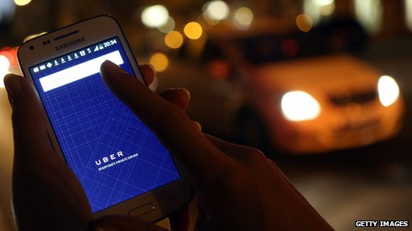
Uber drivers do not need the Knowledge - a test all London black-cab drivers must pass

But in many cities, most notably in London and Los Angeles, local cab firms and drivers have staged protests against the service. In London specifically, black-cab drivers argue that Uber drivers do not have the same regulatory restrictions imposed on them, creating an uneven playing field. Among other differences, Uber drivers do not need to pass the Knowledge, a world famous test of the ins-and-outs of London's old streets. Black-cab drivers argue that the Knowledge ensures the best possible route to destinations, rather than relying, as Uber drivers do, on a sat nav. "The Knowledge is the best in the business," Mr Kalanick said, but added he did not think it was essential. "But you will not get anybody who has Knowledge-level skills in a minicab, it's simply not possible. But the consumer should have that choice. "If they can get a reliable ride that's half the price of a black cab, shouldn't they be able to have that choice?"

Wsj Oct 14, 2014

London Taxi App Hailo Leaves U.S. Battle to Uber, Lyft
The taxi app wars have claimed a victim. Hailo Network Ltd., a London-based startup, said Tuesday it would pull out of North America and part ways with one of its founders in the face of intense competition from companies such as Uber Technologies Inc., Lyft Inc. and GetTaxi Inc.
It is a rare retreat in the battle to transform the taxi and car services industry. Services such as Uber have expanded globally in an attempt to change the way people hail cabs or share rides, often bumping up against resistance from traditional taxi drivers or regulators.
More than $1 billion in venture capital has poured into the taxi-app space, as companies test out various models that include sharing costs with other passengers, using regular drivers outside of the taxi system, and working within the regulated taxi system. But some companies are also testing the limits of the law, and the patience of drivers, running into problems with regulators across the U.S. and Europe.
Hailo has taken a different approach by first trying to win over taxi drivers. Founded in London in 2011 by three former cab drivers, Hailo initially focused on the traditional taxi industry — such as yellow cabs in New York City and black cabs in London. The company tried to provide a digital alternative to street hails.
Recently Hailo pivoted, opening up its services to drivers who take calls through a central dispatch. That angered London taxi drivers, who saw the move as a betrayal.
Chief Executive Tom Barr said the decision to pull out of North America was because of the “astronomical marketing” costs “required to compete.” Mr. Barr said the company would concentrate on expansion in Europe and Asia.
The company said it would lay off 40 employees, not including drivers who used the service as a way to pick up fares.
Co-founder Jay Bregman, who has left the company, didn’t respond to requests for comment. Mr. Barr said that Mr. Bregman “by his own admissions has taken the business to the level he can.”
In a 2013 interview with The Wall Street Journal, Mr. Bregman said there was “plenty of room for more than one in the market,” referring to Uber.
Meanwhile, Israel-based competitor GetTaxi Inc. said it was growing in New York City, helped by a promotion of $10 rides anywhere in Manhattan.
“We definitely understand Hailo’s decision to pull out of the U.S. market, it’s a competitive space,” said Rich Pleeth, GetTaxi’s chief marketing officer. But he said the company was growing and would see its first profitable quarter worldwide in 2015.
Meanwhile, Israel-based competitor GetTaxi Inc. said it was growing.
“We definitely understand Hailo’s decision to pull out of the U.S. market, it’s a competitive space,” said Rich Pleeth, GetTaxi’s chief marketing officer. “However we’re currently experiencing 3000% growth in New York.”

http://jp.wsj.com/news/articles/SB10001424052702304826804579619272713612770?mod=uzabase

Maaxi
http://taxileaks.blogspot.jp/2014/09/maaxi-driver-app.html
https://www.youtube.com/watch?v=HE2DS7cX2kY

Monday, September 15, 2014
Maaxi The ‘Black Cab Only’ Sharing App Launches In London Today.

BLACK CABS ONLY, FOREVER!
Maaxi, the next generation taxi app for black cabs only forever, will start pre-registration of taxi drivers, Monday 15th September, toward formal sign up and download in just a few weeks.

The passenger App, conceived 24 months ago, is a journey planner much like Google Maps or Citymapper but unlike Google Maps’ Uber option and Citymappers’ Hailo option, the App offers black cabs only in shared and normal fare format.

This means that passengers can choose to upgrade from a train to a black cab door-to-door, something that they cannot do with other Apps (the price of an Uber or a Hailo is 5 to 10 times higher than public transport versus 1.5 times higher with a fully shared taxi on Maaxi).

In addition, unlike in Google or Citymapper, in Maaxi the taxi booking is done within the App.

Nat Rothschild, representing Maaxi, said:
“This weekend saw articles highlighting new congestion charge plans along with a the lack of available funds for transport investment.

Hackney carriage drivers’ are critical to resolving London’s transport problems and I am betting with Maaxi on the increasingly important role they must play in TfL’s plans to address the future of transport in London.”

Watch the videos and let us know what you think via the comments page.

Editorial comment.
When I first heard about a ride sharing app, I didn't think it had a chance of getting off the ground.

But then I remembered my time on ComCab, Dial A Cab and Radio Taxis, where accounts with hotel staff or London Underground workers, often marry up in the early hours and it works quite well.

This new app promises to creat new work, rather than just recycle existing potential passengers. No other app out there is offering this.

There are many who can't afford to use Taxis as much as they would like, but sharing with like minded people will bring individual costs down, allowing customers to use Taxis more often.

They can chose to share, but can also book a journey on their own. The choice is theirs.

People already share, everyday on tubes and buses but have to make their own way to and from stations and bus stops. We would be offering a service to pick up and deliver door to door.

And the best attribute of this app is, it's completely free for the driver to use, only the passenger pays.

Quote from Twitter:
"ehail is free, App is free, punters not drivers pay for shared rides. Drivers will make around 30% more with shared rides!!"

2 comments:
Anonymous said...
My concern is this could turn into hailo again. What if Mr Rothschild does not get the return he wants?. Will use private hire or charge drivers. What if the other apps like Hailo use this system and only charge the driver , as they do at the present. The public will switch over to hailo/ Uber. Lots of questions need to be answered.
Be very careful.

